~A000-Asia-China-Xian-Shanxi Province-Cong-Cubic Cylinder-One Tier-Jade-W Zhou Dyn. (1046–771 BCE)
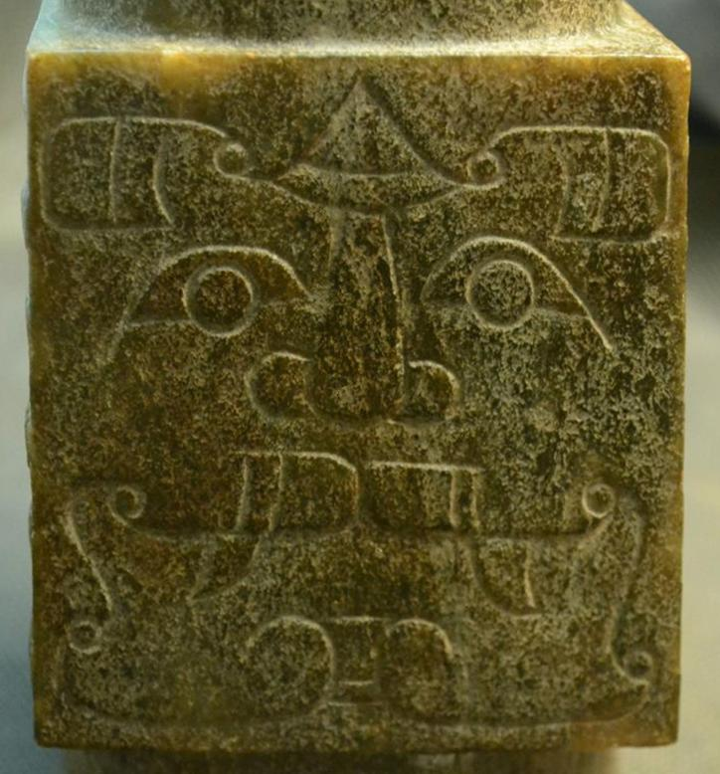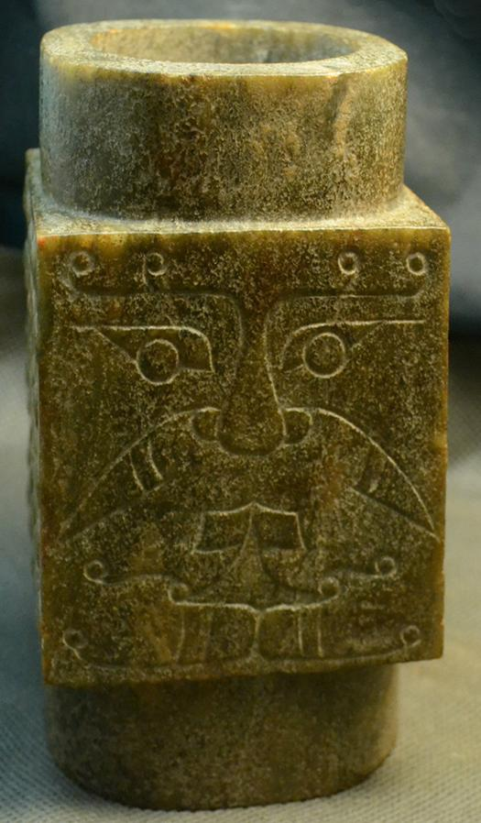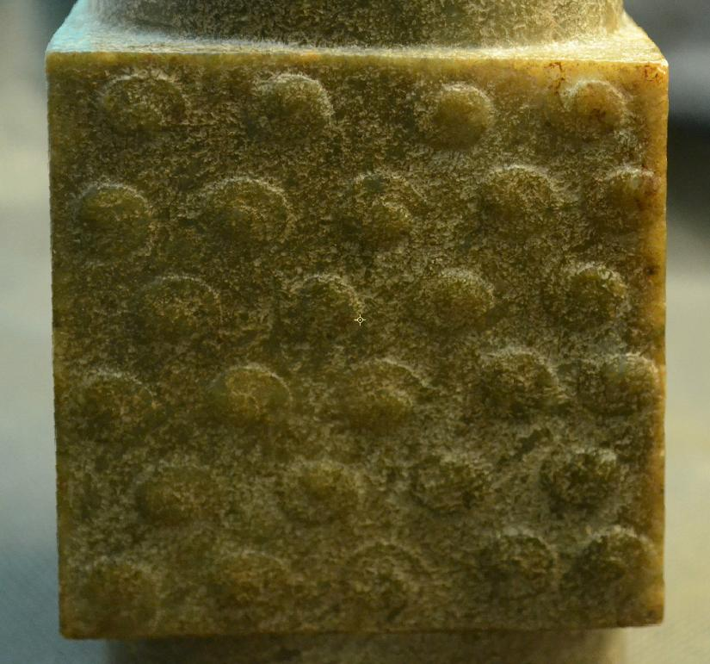
Fig. 2. Male god of earth or soil with his symbols of 2 + 2 and in his square form derived from the idea of the square shape of the earth.

Case: 5

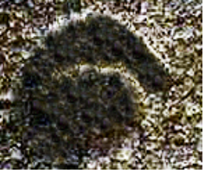
Cloud motifs have the shape of a wild boar. These cloud motifs are placed in an arrangement of 4-5-4-5-4-5 on the opposing sides of the cube. This numerology is composed of two pairs of two alternating with five, 2 and 5 being the based on the symbolism of the figures 5 and 2 which are emblazoned on the square side of the cube, which is the shape of the Earth. Earth is of the color yellow, which is the color of the jade used here (See Laufer 1912: 149).
Cloud motifs are a sign of heaven. Since the cloud motifs were carved as coiled wild boars, this would have been an auspicious omen for those who were to sacrifice a wild boar.

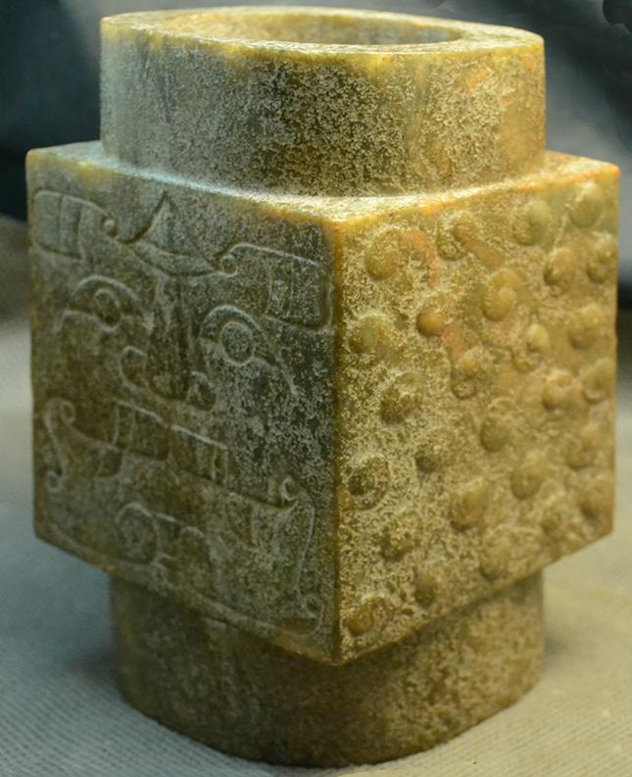

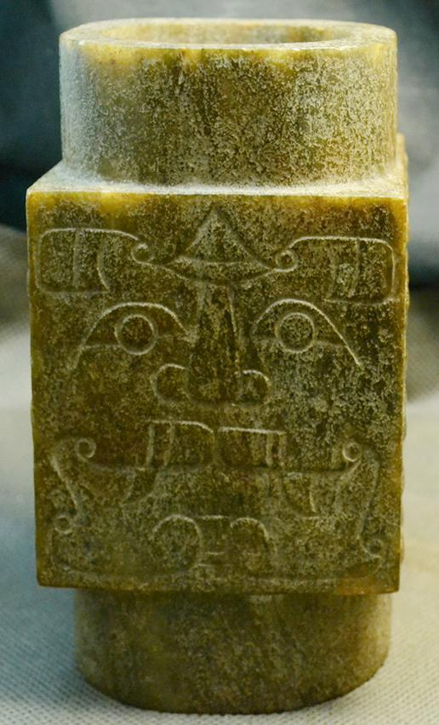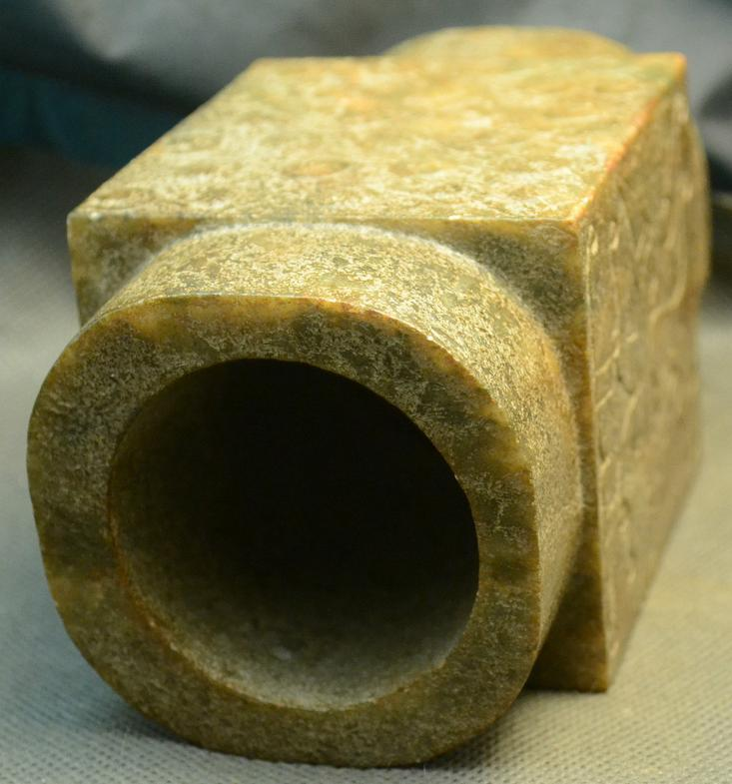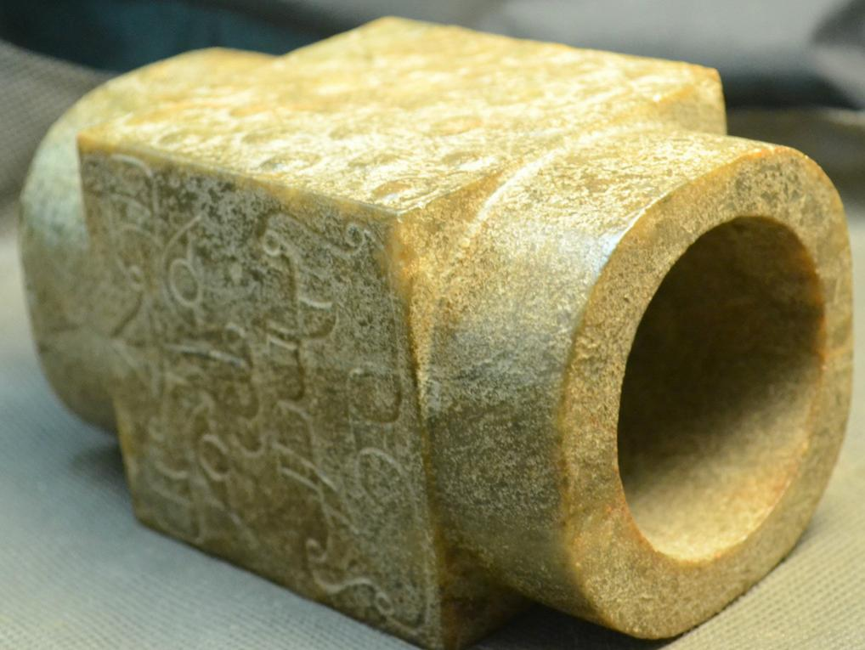

Accession Number:
Formal Label: China-Liangzhu-Cong square cylinder-Two Tier-Jade- early Liangzhu Period, ca. 3200 BCE
Display Description:
This Cong is in the yellow color of Earth. The cylindrical tube represents both the birthing canal through which all life emanates and correlatively the pit into which sacrificial victims are offered (Li-Ki 20 [Tsi-fah] from Couvreur, Liki II, 259). Opposing masks of the cubic faces represent Mother Earth and the Son of the Sun, probably an anthropomorphic ancestral figure associated with fructifying soil. On the other two opposing faces are cloud motifs.
Liangzhu Congs are comprised of a square or nearly square exterior prism enclosing a circular inner column. The square represents Eh and the circular column represents Heaven. The color of the cong also hints at this symbolism. The late Zhou ritual classic, Zhou Li p, Chou Li wg (周禮) in the middle of the 2nd century BCE, compiled some three thousand years after the present example was manufactured, stipulated that "jade is used to make the six instruments by which the king worships Heaven and Earth and the four quarters [Spring, Summer, Autumn, Winter]. By the green bi (p), pi (wg) [round jade disk], heaven is worshipped; by the yellow cong (wg), tsung (p), Earth [is worshipped]" (Biot 1851). This cong may have been once more yellow, and its present creamy off-white color is thought to have been produced by minerals leaching from the decaying body into the nephrite during burial, a process that occurs in the first weeks after interment.

This one-tier cong has a wide opening that is approximately 7/8 of the implement's outer diameter. The significance of this proportionality is unknown. According to Hayashi Minao, a Japanese expert of Liangzhu jades, two-tier congs are the earliest and were produced in the early Liangzhu period, ca. 3200 BCE, based on archaeologically excavated examples (Hayashi 1973; Hayashi 1990:6). In later Liangzhu phases congs were elongated with multiple tiers. In the early Liangzhu period the central hole was characteristically wide, as in this example, and as the congs were elongated the central holes, generally, were narrowed.

The square exterior is comprised of single, repeated cartouche-like panels on each of the four corners representing an anthropomorphic mask suggesting a shamanic trance. This iconography undoubtedly harkens back to a pre-Neolithic period when shamanic imagery was the symbolism of hunter-gatherers and was the imagery that was inscribed on petroglyph panels. Indeed, Hayashi Minao argues that the name of the cong/tsung derived from zhu/chu meaning "master" which we expand to "master of animal powers" (Hayashi 1990:6).

The interior of the column was believed to be the conduit for the communication with the numinous spirits that were depicted on its external surface.
As congs became more elongated the original paring of animal and anthropomorphic masks became obliterated, with only the human mask surviving. At the end point of this trend the mask became mere ridges that no longer had even an abstract likeness to a human mask. Finally, the cong was no longer made of jade the divine substance but of wood. Its secularization was complete.
The evolution of the cong mask, therefore, appears to have undergone a transformation from that of a shamanic device of invoking animal powers to that of purely human ancestral powers by eliminating the animal panels to that of a series of purely abstract ridges suggesting a semiological transformation as well: from symbolizing the numinous power of shamanic elders to symbolizing the numinous power of ancestors to symbolizing the historical succession of generations purely abstractly.

LC Classification: NK5750.2.A1
Date or Time Horizon: Liangzhu culture, lower Yangzi River Valley, early Liangzhu Period, ca. 3200 BCE Geographical Area: Liangzhu culture, lower Yangzi River Valley
Map:
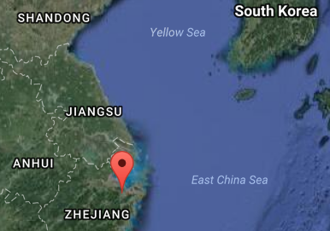
Source: Google Earth
GPS coordinates:
Northeast corner: N 30°24'48", E 120°00'17"
Northwest corner: N 30°24'41", E 119°58'58"
Southeast corner: N 30°23'20", E 120 00'19"
Southwest corner: N 30°22'55", E 119°58'28"

Cultural Affiliation: Liangzhu culture, lower Yangzi River Valley, 3300-2250 BCE
Medium: Jade
Cultural Affiliation: Liangzhu
Medium: jade
Dimensions: Height:5.375" Width:3" Depth:3"
Weight: 1244 grams
Condition: original
Provenance:
Discussion:
Liangzhu (3400–2250 BCE) in Yuhang County, Zhejiang, was a highly stratified Neolithic jade city-state in the Yangtze River delta where élites controlled a sphere of influence north to Shanxi and south to Guangdong.
DNA recovered from Liangzhu graves shows high frequencies of Haplogroup O1 linking it with modern Austronesians.
The use of jade and other expensive wares (such as silk, lacquerware, and ivory) in grave sites characterized the social symbolism of Liangzhu élites. About 4200 BP Liangzhu succumbed to a series extreme floods since the cultural layers are interrupted by intrusions of mud and sand. It is also possible that an asteroid created Taihu lake 4500 BP, which contributed to its demise.

References:
Biot, Jean Baptiste. 1851. Le Tcheou-li: ou, Rites des Tcheou. Paris: Imprimerie nationale, 1851. 3v.

Chang, K.C., Xu, P. and Lu, L. 2005. The formation of Chinese civilization: an archaeological perspective. New Haven: Yale University Press.

Hayashi, Mineo. 1990. On the Chinese Neolithic jade Tsung/Cong, Artibus Asiae, 50(1/2):5-22.

Hayashi, Mineo. 1973. Toyo Gakuho [Journal of the Research Dept. of the Toyo Bunko] 45:1-57.

Hayashi, Minao. 林巳奈夫. 1991. Chūgoku kogyoku no kenkyū. 中國古玉の研究. Tōkyō : Yoshikawa Kōbunkan; 東京 : 吉川弘文館, 1991.

Laufer, Berthold. 1912. Jade a study in Chinese archaeology and religion. Field Museum of Natural History, Publication 154, Anthroplogical series, vol. X. Chicago.

Li, Hui; Huang, Ying; Mustavich, Laura F.; Zhang, Fan; Tan, Jing-Ze; Wang, ling-E; Qian, Ji; Gao, Meng-He; Jin, Li. 2007. "Y chromosomes of prehistoric people along the Yangtze River," Human Genetics 122: 383–388.

Wu, Li. 2014. "Holocene environmental change and its impacts on human settlement in the Shanghai Area, East China," Catena. 114: 78–89

Zhang, Chia; Hsiao-Chun, Hung. 2008. "The Neolithic of Southern China–Origin, Development, and Dispersal,"Asian Perspectives. 47:2, 309–310.

Zhou Ying. 2007. "The Dawn of the Oriental Civilization: Liangzhu site and Liangzhu culture. Beijing: China Intercontinental Press.

